Appetizers

Calamari $12.99
Tender calamari rings dipped in Italian
seasoned bread crumbs and lightly fried

Chicken Strips $9.99
Five classic chicken breast strips dipped in tempura batter and fried to golden brown

Shrimp Skewers $13.99
Wild caught rock shrimp skewered with red onion and fire grilled, served with our house Thai peanut dipping sauce

Onion Rings or Fries $8.99
Your choice of crispy Onion Rings, Sweet Potato Fries or French Fries
Upgrade to Garlic Parmesan fries $10.99

Bruschetta $9.99
Toasted baguette topped with a mix of fresh tomatoes,
garlic, basil, balsamic and parmesan cheese

Crispy Chicken Wings $9.99
Six crispy wings tossed in your choice of BBQ, Buffalo,
Sweet Cilantro Chili or Teriyaki sauce

Delta Artichoke $9.99
Steamed and grilled, plated open faced with garlic aioli

Tortilla Chips and Salsa $7.99
Fresh fried tortilla chips and house made salsa

Soup and Salads

Delta Signature Salad $13.99
Field Greens, tomatoes, cucumbers, shredded carrots, red onion and feta cheese served with balsamic dressing
Grilled Chicken $20.99 Sautéed Shrimp $23.99 Grilled Salmon $23.99

Caesar Salad $13.99
Crisp Romaine lettuce, parmesan cheese, garlic croutons and traditional dressing
Grilled Chicken $20.99 Sautéed Shrimp $23.99 Grilled Salmon $23.99

Crispy Buffalo Salad $14.99
Romaine lettuce, green onion, shredded mozzarella cheese, bacon, avocado, tomato and Crispy Buffalo Chicken. Accompanied by house made Buttermilk Ranch dressing.

Classic Chili $7.99
Traditional hearty beef chili simmered with beans and a homemade blend of seasonings. Topped with cheese and onion
Bread Bowl $10.99

Fridays Only*
Waterfront Clam Chowder $7.99
Martha’s signature recipe full of plump clams and fork tender potatoes in thick cream chowder
Bread Bowl $10.99

Tax and gratuity not included*
18% gratuity will be added to groups of 6 or more

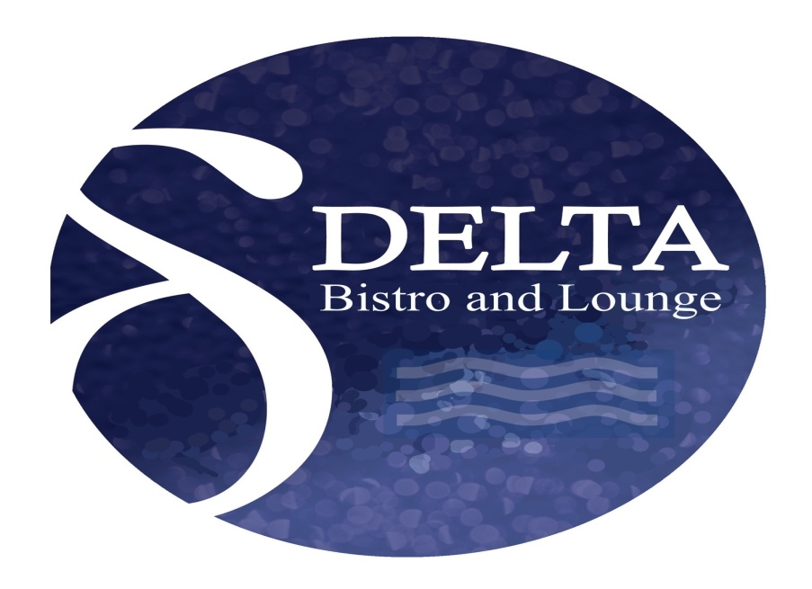
Burgers and Sandwiches
All burgers and sandwiches served with French Fries or Salad. Add $2 for Onion Rings or Sweet Potato Fries*

Delta Burger $15.99
8oz Gourmet beef patty fire grilled and topped with cheddar cheese, lettuce, tomato, onion and pickle
Add Avocado $3 Add Bacon $3

Chicken Avocado Sandwich $14.99
Grilled chicken breast, avocado, lettuce, tomato, shaved onion dressed with chipotle ranch and piled high on a ciabatta roll

Crispy Cod Sandwich $15.99
Crispy cod filet topped with a tangy purple cabbage slaw and served on a crusty steak roll spread with classic tartar sauce

Cali BLT $14.99
Thick slices of crispy bacon, lettuce, tomato, avocado piled on a ciabatta roll spread with garlic aioli

Prime Rib Philly Cheesesteak $16.99
Hand cut prime rib covered in sautéed bell peppers, mushrooms and onions. Topped with melted mozzarella cheese and served on a crusty steak roll

Waterfront Pizza

Cheese Pizza $15.99
Our traditional cheese pizza

Margherita Pizza $17.99
Fresh tomatoes, basil, garlic and olive oil

Pepperoni $19.99
Deli sliced pepperoni and cheese

Delta Combo $23.99
Fresh bell peppers, onions, mushrooms, black olives, pepperoni and Italian sausage

Tax and gratuity not included*
18% gratuity will be added to groups of 6 or more
Entrees
All entrees served with choice of Chili, House or Caesar salad. Add six sautéed shrimp to any meal $10.00. Upgrade to Loaded Mashed Potatoes $4

Grilled Salmon $24.99
Fresh Pacific Salmon grilled and topped with a sweet chili garlic sauce. Served with cilantro lime rice and seasonal vegetables.

Scallops and Rock Shrimp $31.99
Three of each, pan seared with garlic butter and accompanied by brochette rice and seasonal vegetables.

Chicken Jerusalem $24.99
Sautéed chicken in a succulent mushroom and artichoke herb cream sauce and served with mashed potatoes and seasonal vegetables

Teriyaki Chicken Rice Bowl $19.99
Steamed Jasmine rice with fresh vegetable medley, teriyaki sauce and grilled chicken
Shrimp $23.88 Salmon $24.99

Fettuccine Alfredo $17.99
Al Dente Fettuccine pasta tossed in our rich and creamy Alfredo sauce and topped with parmesan cheese
Chicken $24.99 Shrimp $27.99

Roasted Red Pepper Tortellini $17.99
Cheese tortellini tossed in a creamy and flavorful roasted red pepper sauce and topped with parmesan cheese
Chicken $24.99 Shrimp $27.99

Smothered Chopped Steak $19.99
Seared hamburger steak, smothered in a Marsala demi glaze with mushrooms, garlic and onions. Presented atop fluffy mashed potatoes and served with seasonal vegetables

Ribeye Steak $39.99
14oz hand cut flame grilled ribeye steak topped with blackened seasoned compound butter. Served with mashed potatoes and seasonal vegetables

Tax and gratuity not included*
18% gratuity will be added to groups of 6 or more
Dessert
Vanilla Bean Ice Cream $3.99
Chocolate, caramel or strawberry drizzle and whipped Cream
Chocolate Brownie Sundae $7.99
Warm chocolate chip brownie topped with vanilla bean ice cream, caramel drizzle, whipped cream and a maraschino cherry
Mixed Berry Tart $6.99
A warm berry tart with a rustic crust, fresh from the oven and topped with strawberry drizzle and whipped cream
A la mode $8.99

Sweet Potato Pie $6.99
Made from scratch sweet potato pie, full of this season’s spices and set in a flaky buttery crust
A la mode $8.99
Beverages
Soft Drinks and Iced tea $4
Hot Cocoa $5
Hot Tea $4
Starbucks Coffee $5

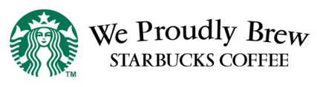

Tax and gratuity not included*
18% gratuity will be added to groups of 6 or more

